**Week–2**

**Hands-on Exercises**

**Exercise 1: Control Structures**

**Scenario 1:** The bank wants to apply a discount to loan interest rates for customers above 60 years old.

* + **Question:** Write a PL/SQL block that loops through all customers, checks their age, and if they are above 60, apply a 1% discount to their current loan interest rates.

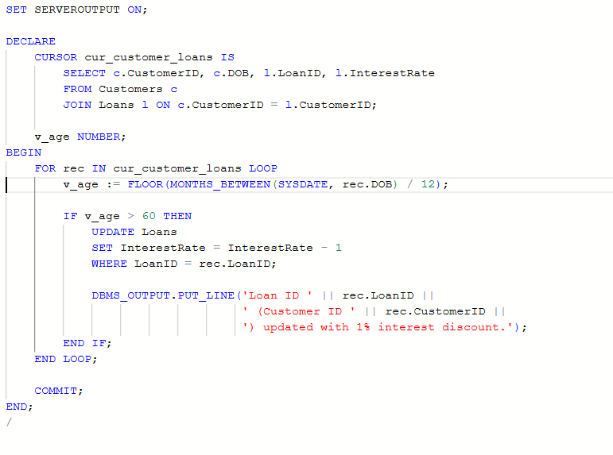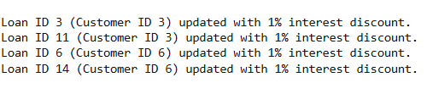

**OUTPUT:**

**Scenario 2:** A customer can be promoted to VIP status based on their balance.

* + **Question:** Write a PL/SQL block that iterates through all customers and sets a flag IsVIP to TRUE for those with a balance over $10,000.

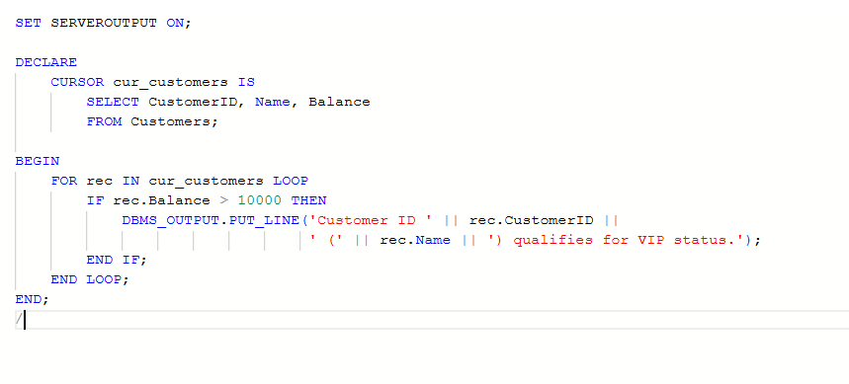

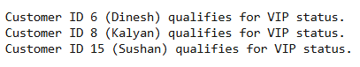**OUTPUT:**

**Scenario 3:** The bank wants to send reminders to customers whose loans are due within the next 30 days.

* + 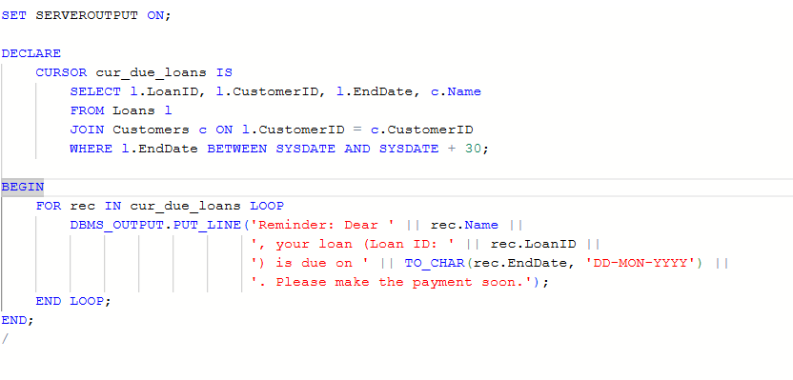**Question:** Write a PL/SQL block that fetches all loans due in the next 30 days and prints a reminder message for each customer.

** OUTPUT:**

**Exercise 2: Stored Procedures**

**Scenario 1:** The bank needs to process monthly interest for all savings accounts.

* + 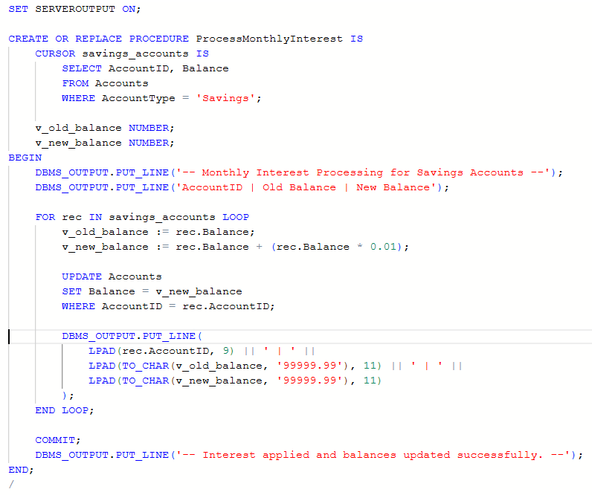**Question:** Write a stored procedure **ProcessMonthlyInterest** that calculates and updates the balance of all savings accounts by applying an interest rate of 1% to the current balance.

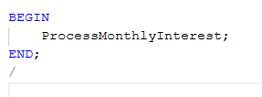

**OUTPUT:**

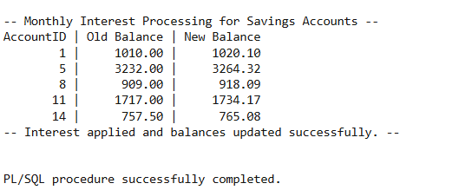

**Scenario 2:** The bank wants to implement a bonus scheme for employees based on their performance.

* + **Question:** Write a stored procedure **UpdateEmployeeBonus** that updates the salary of employees in a given department by adding a bonus percentage passed as a parameter.

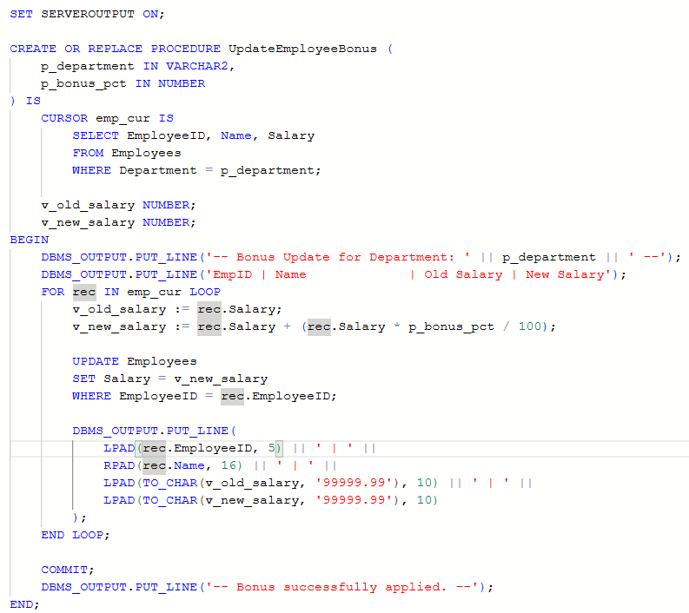

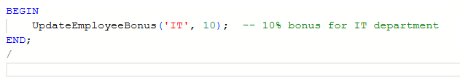

**OUTPUT:**

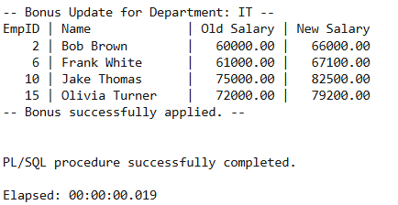

**Scenario 3:** Customers should be able to transfer funds between their accounts.

* + **Question:** Write a stored procedure **TransferFunds** that transfers a specified amount from one account to another, checking that the source account has sufficient balance before making the transfer.

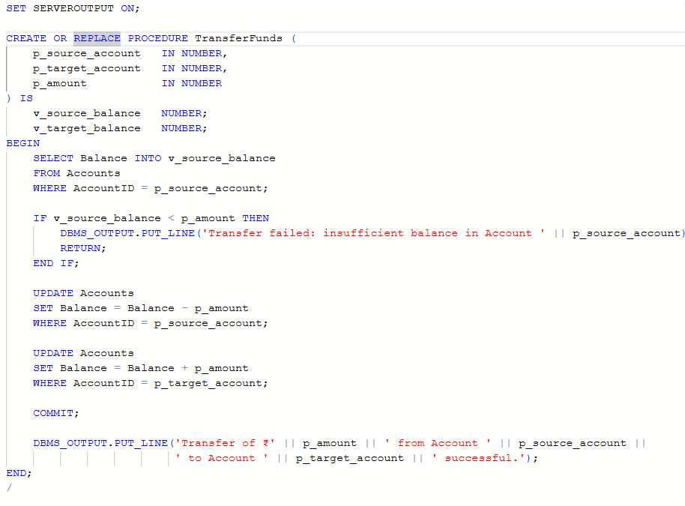

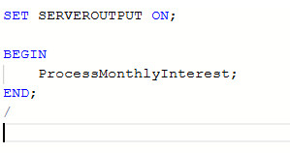

**OUTPUT:**

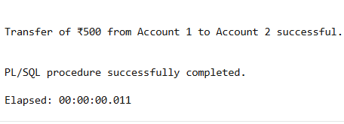

**Exercise 1: Setting up JUnit4**

**Scenario 3:** You need to set up Junit in your Java project to start writing unit tests.

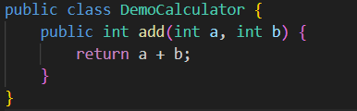

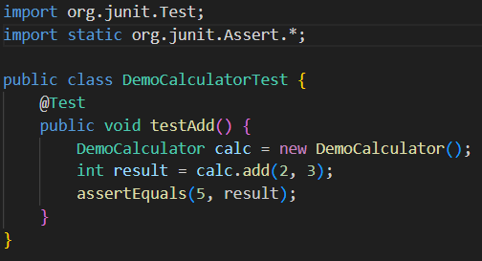

**OUTPUT:**

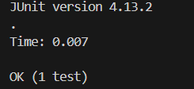

**Exercise 3: Assertions in JUnit**

**Scenario:** You need to use different assertions in JUnit to validate your test results.

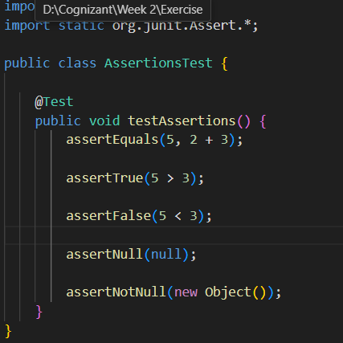

**OUTPUT:**

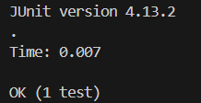

**Exercise 4: Arrange-Act-Assert (AAA) Pattern, Test Fixtures, Setup and Teardown Methods in JUnit**

**Scenario:** You need to organize your tests using the Arrange-Act-Assert (AAA) pattern and use setup and teardown methods.

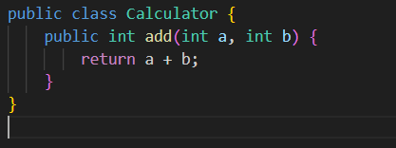

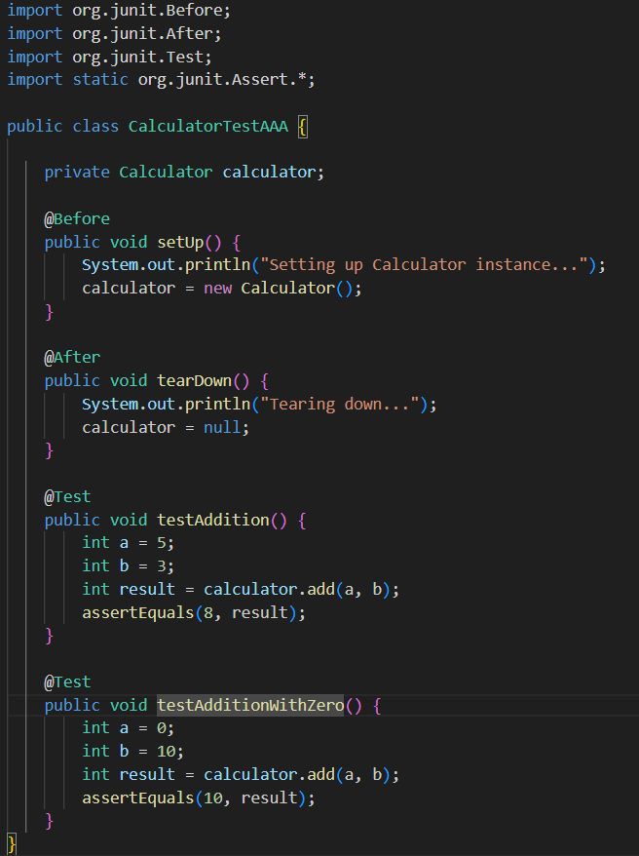

**OUTPUT:**

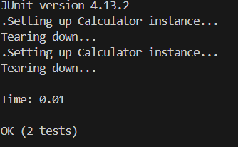

**Exercise 1: Mocking and Stubbing**

**Scenario:** You need to test a service that depends on an external API. Use Mockito to mock the external API and stub its methods.

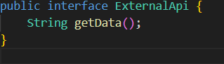

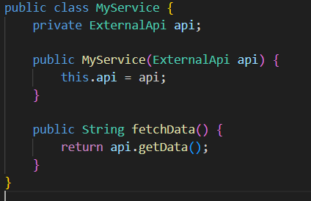

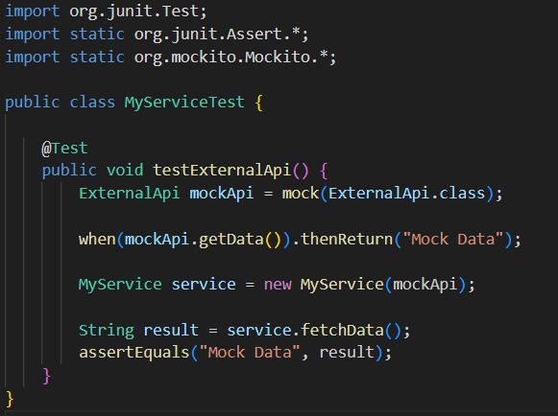

**OUTPUT:**

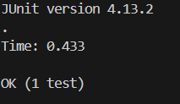

**Exercise 2: Verifying Interactions**

**Scenario:** You need to ensure that a method is called with specific arguments.

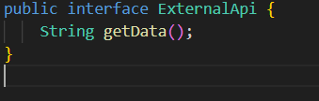

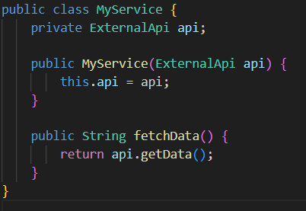

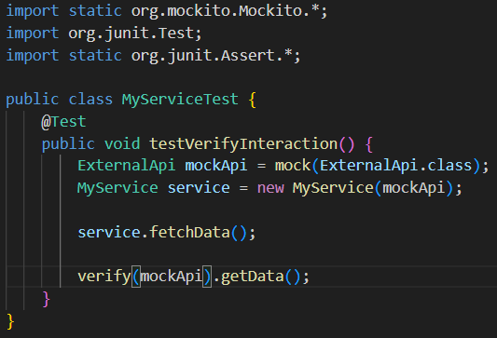

**OUTPUT:**

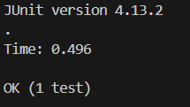

**Exercise 1: Logging Error Messages and Warning levels**

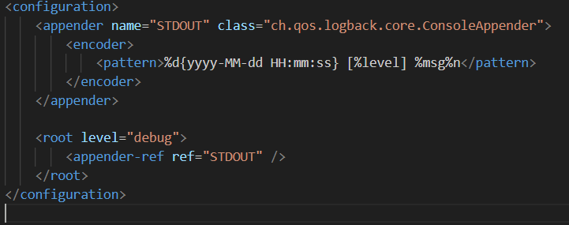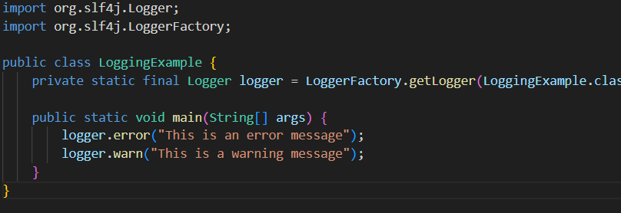**Task:** Write a Java application that demonstrates logging error messages and warning levels using SLF4J.

**OUTPUT:**

